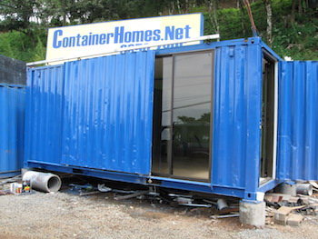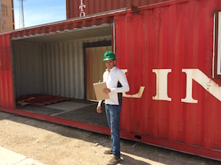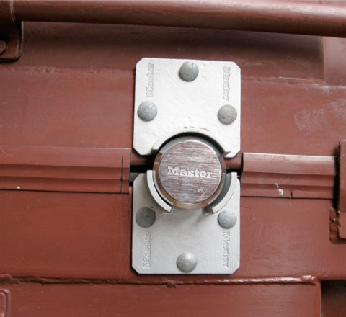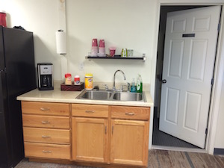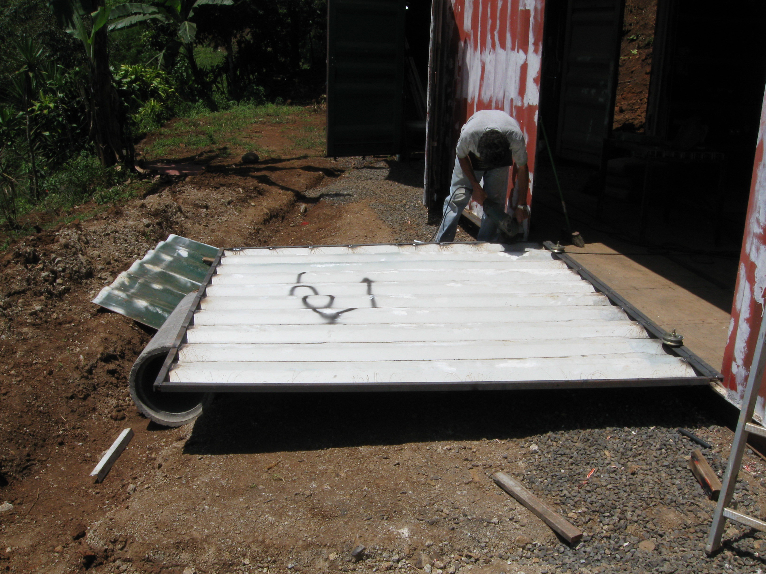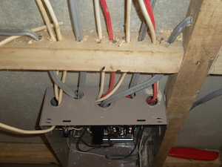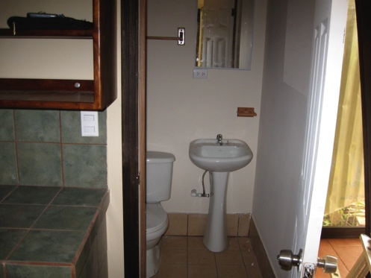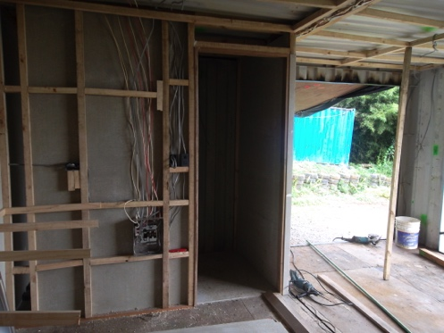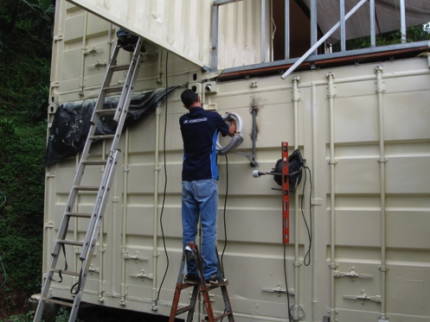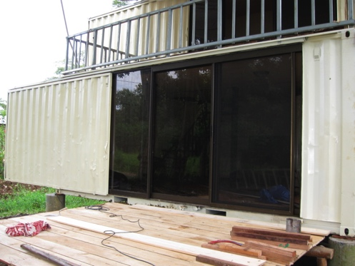

* ContainerHomes.NeT

COSTA RICA

PRICING

[**ContainerHomes.net**](http://www.containerHomes.net)

**James Lee**

**San Ramon, Costa Rica (506) 8-307-8666**

**USA Contact: (512) 650-0231 Austin, Texas**

[info@containerhomes.net](mailto:info@containerhomes.net)

C

20ft: $2,900

40ft $3,500

$9,500

$18,500

### Used 20ft & 40ft Shipping Containers

### 40ft Shipping Container

### Home

### 320 sq/ft

### 20ft Shipping Container

### Home

### 160 sq/ft

## Option 3

## Option 1

## Option 2

**Standard Features:**

1. Fully finished interior walls.
2. Fully equipped with electricity and water.
3. Fully finished bathroom. One kitchenette.
4. Sanded down re-finished wooden floor.
5. Outside primed and painted.
6. One Sliding Glass Door.
7. Locks.

**Not Included in the above price:**

1. **Transportation**
2. **Installation**
3. **Permits**

##### Glass Door size 3Mx 2.4M

##### Steel Sliding Door Included

##### Security Locks

##### Painted both inside and outside

##### Refinished Floors

##### Kitchenette

##### Electricity

##### Finished Bathroom

##### Finished Walls